

Ohio Valley Society of Cosmetic Chemists
“Sensism”
Secrets of the Senses

Wednesday November 17, 2004
Pascale Rossi of Uniqema Inc. will review the findings of a study conducted by Dr. Charles Spense of Oxford University and sponsored by ICI on "sensism". She will discuss how one can create imaginative solutions to the challenges of the modern lifestyle and delight the senses of consumers. She will talk about ways to engage the senses in a new way to develop products for consumers’ lifestyles.

Pascale will also share the trends in Personal Care (demographics, lifestyles, global and ethnic considerations, etc), claims substantiation, multi-functionality, sensations (forms), and performance and delivery through formulation expertise.

Pascale Rossi is a Skin Care Chemist at Uniqema. Pascale's experience includes formulation, product development and technical support for US and Latin America. Ms. Rossi received her Master's Degree in Physical-Chemistry of Formulation from the University of Science and Technologies of Montpellier in the South of France. She is currently an active member of the SCC and the CTFA. Pascale recently had articles published in both HAPPI and Cosmetic & Toiletries magazines and was a presenter at the Health & Beauty Expo in NYC in September 2003.

Location: Maggiano’s Little Italy
7875 Montgomery Rd
Kenwood Towne Center

Time: 5:30 pm – 6:00 pm Social time
6:00 pm – 7:00 pm Dinner
7:00 pm – 8:00 pm Speaker

Fee: Members $40
Students $15
Non-members $50
2004 Officers

Chair:
Sirlei Waterhouse
513-455-5513
sirlei.waterhouse@kaobrands.com

Chair Elect:
Salvadore Pliego
513-627-4728
pliego.s@pg.com

Secretary:
Susan Littell
513-455-5533
susan.littell@kaobrands.com

Please contact Andrew DiMuzio to confirm your attendance by November 12

Andrew.dimuzio@kaobrands.com
Fax: 513-263-7657
Phone: 513-455-7548

Directions to: Maggiano’s Little Italy
7875 Montgomery Rd
Kendwood Towne Center

From Downtown: Take I-71 North to Kenwood Rd Exit
Turn left off the ramp. Turn right onto Montgomery Rd.
Turn left into Kenwood Towne Center. Maggiano’s Little Italy entrance faces Montgomery Road as part of the Mall (next to Cheesecake factory).

Note from the Chair:
On November 17 we will have the installation of the 2005 board of directors. Salvador Pliego, current Chair-elect, will become the Chair for 2005 and the other board positions will be filled when we receive your ballots. At this time you should have received the SCC Ohio Valley Chapter ballot from Susan Littell. Although, there is only one nominee for each of the board positions please vote and return the ballot to Susan by October 28.

If you would like to become more involved in the SCC Ohio Chapter, please contact Salvador Pliego. There are many different opportunities to get involved.

For me, chairing the SCC Ohio Valley Chapter turned out to be more work than I expected and much more fun, exciting and rewarding than I ever imagined. I had the opportunity to work with great people who helped make this a wonderful experience.

I would like to thank, Eric Abrutyn for pursuing excellent speakers for the meetings, Andrew DiMuzio for selecting excellent locations, Susan Littell for doing whatever needed to be done, Dave Mosko for organizing a great golf outing with no rain, Howard Epstein for updating the website, Joe Jendzio for his many years of service as the Newsletter Editor, Jim Staudigel for his efforts in pursuing new members and helping out in meetings, Paul McOsker, Greg Hillenbrand and Randy Wicket for providing perspective and guidance and Salvador Pliego for his positive views and assistance throughout the year. I also would like to thank all the members of the SCC Ohio Valley for your support and participation and the many suggestions to make our activities. I learned a lot this past year about the SCC and about myself.

Sirlei Waterhouse

"Seeds for Paradigm Shifts in Personal Care" a review by Eric Abrutyn.

The Ohio Valley Chapter held its first ½ Day Symposium on September 1. Attendees were privileged to hear five speakers review the trends in different business not related to cosmetic industry and shared their thoughts regarding innovation.

Dave Muenz, VP of Product Development of Kao Brands presented "Emotivation: The source of real marketplace change". Dave shared his belief that the difference in product success today may be more on the vector of emotional transformation than product performance alone. This transformation takes place when one brings passionate actions into experience. One needs to put themselves in the customers mind and shoes, accessing this knowledge to champion change. One must find time and space to create the environment for innovative thinking.

Nancy Eichstadt, Director of New Business Development & Marketing for Clopay Plastic Products, presented "Brief Industry overview of the Non-Woven Industry". She reviewed the changes in the non-woven industry and how companies use innovation to be competitive and differentiated in a competitive business. She believes that it is important to stay linked to industry trade organizations and use stage gating as a strong part of decision making on new ideas and projects; bringing value to the process. One needs to develop a value-added aspect to overcome the straight pricing pressures. A good example of this was a woven/non-woven multi-layer fabric that duplicates Gore-Tex (tm), but lighter and quieter.

Jack Ballard, National Coatings Manager for Burgess Pigment Company presented "New Advancement of Pigment Extender Technology" as a way to enlighten the participants on how a low cost commodity competes. Jack Ballard sells only one product; clay from Georgia called Aluminum Silicate. The Aluminum Silicate is a commodity that cost two cents a pound. Transportation is more expensive than the product. In order to be competitive and innovative, it is important to understand the product, the customer, the business and to listen to the customers needs and translate them back into new ideas and approaches. By knowing your product you can add value and mute some of the cost pressures.

Dr. Andress Johnson, Technical Development Manager Surfactants for Akzo Nobel Surface Chemistry, presented "A review of formulations used in Automotive Care". The focus for the Automotive Care business is "better cleaning solutions". Akzo creates new product concepts by learning and understanding consumer habits and practices. This allows them to deliver unique new benefits through existing perceived needs (e.g., P&G's new No Dry Rinse where the water no longer beads up on the car surface).

Bill Richardson, Marketing Manager Savory Business of Givaudan Flavors, presented "Overview on Flavor Delivery Systems". Case histories were used to highlight how one can bring innovations right to the customer’s table or doorstep. The customer can create their own flavor using a Givaudan kit, right in the conference room. This responds to the current sense of urgency in a rapid idea to market environment. Establish position of innovations by moving past low cost & customer service competitors through innovation. Speak the vocabulary of the customer, go directly to your customers customer to see how they do it, then capture and recreate linked to trends and lifestyles.

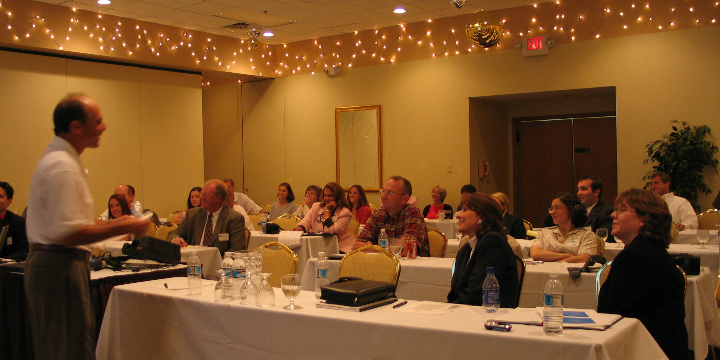

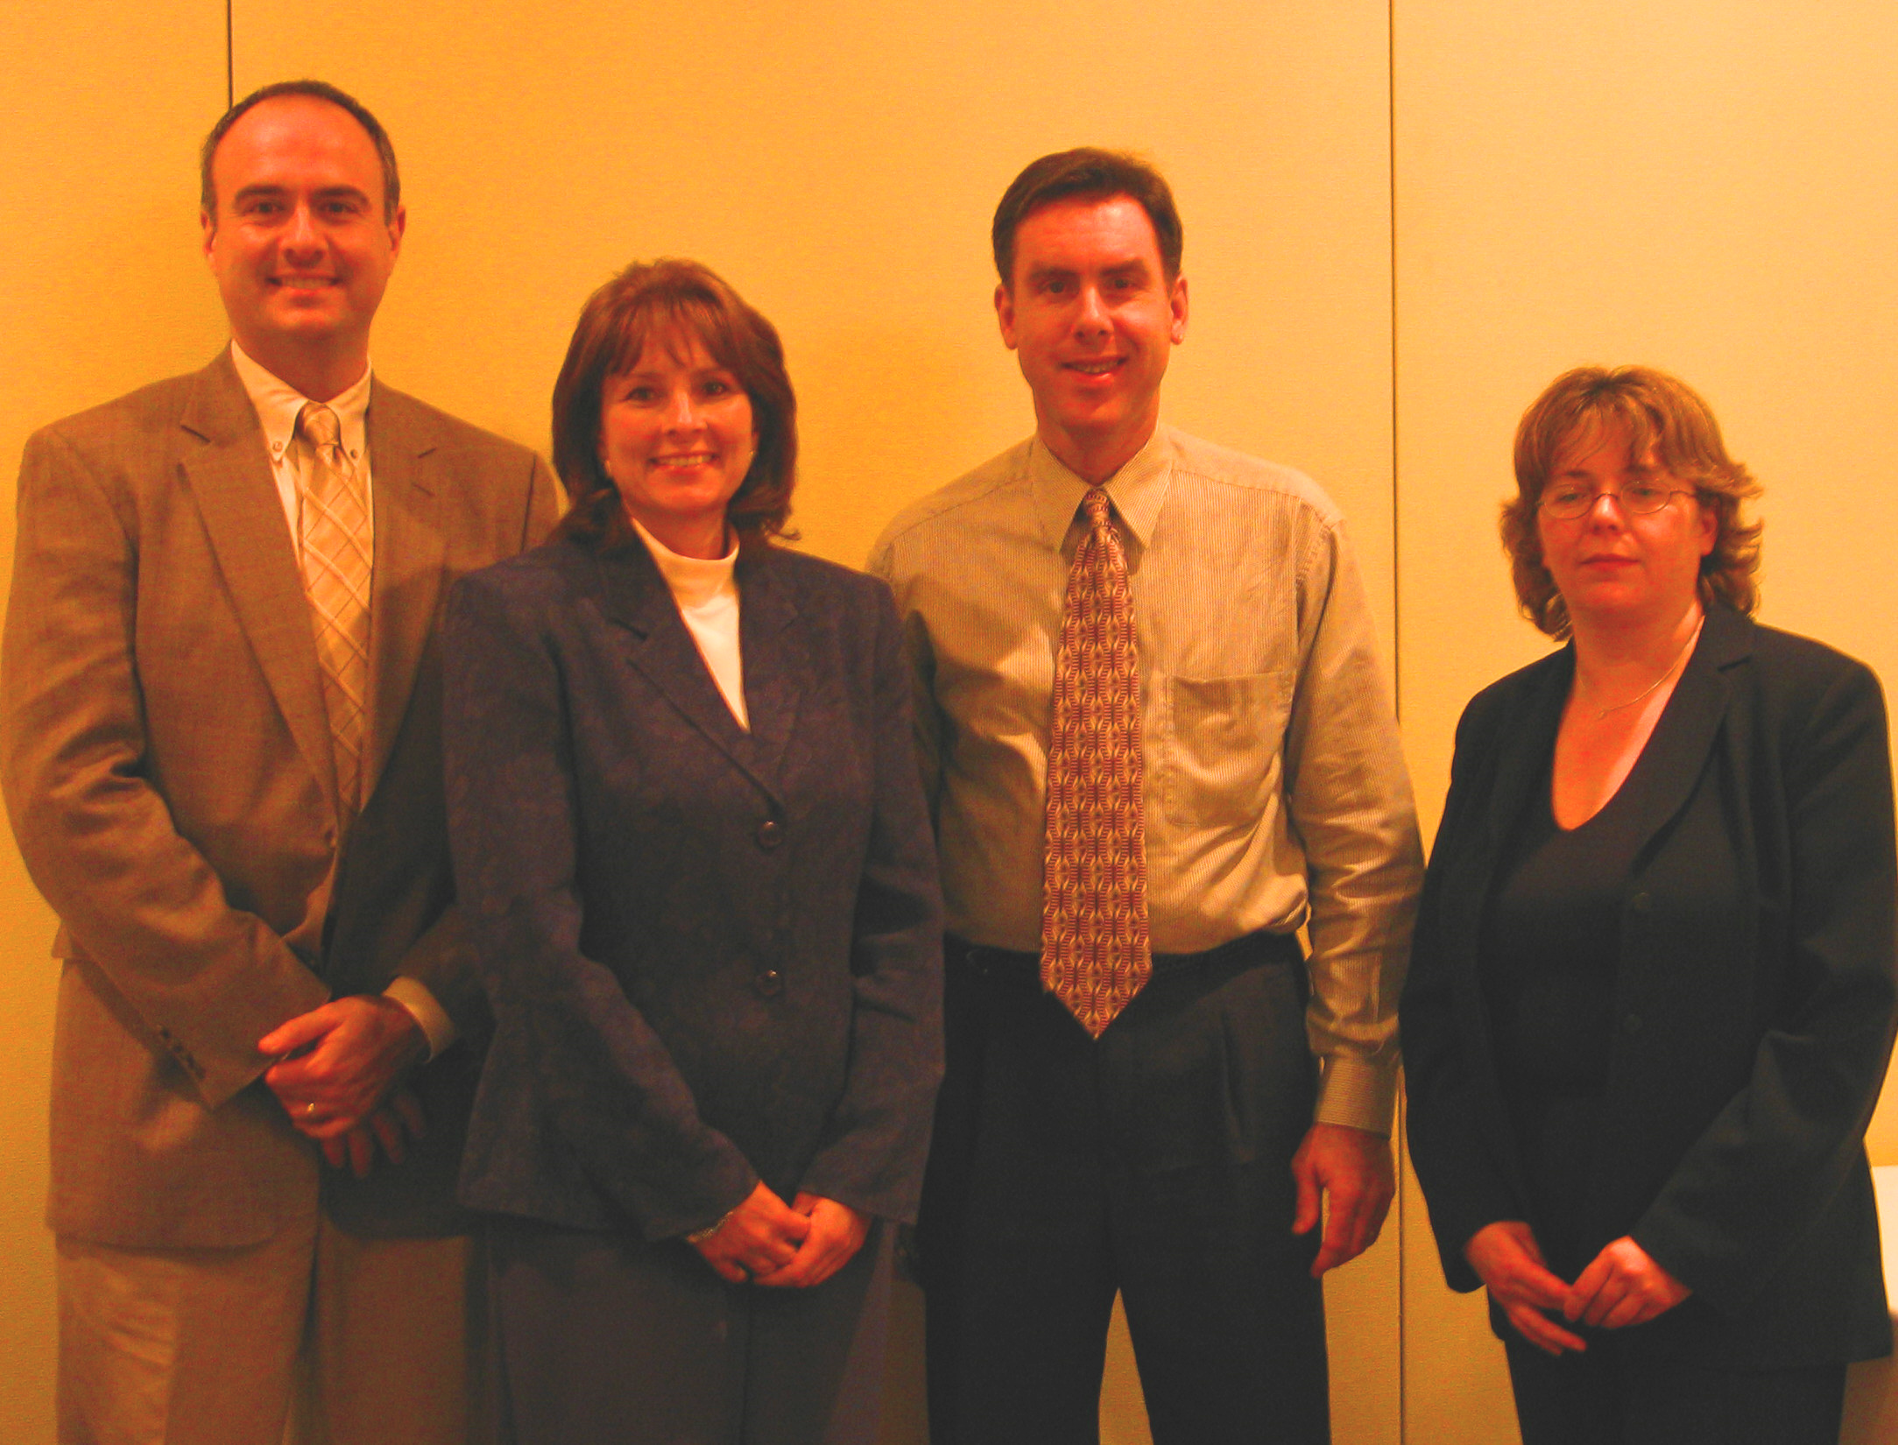
Speakers of the "Seeds for Paradigm Shifts in Personal Care" Symposium
(left to right)
Dave Muenz, Nancy Eichstadt, Bill Richardson, Dr. Andress Johnson not pictured Jack Ballard.

So as a summary, here is what the five speakers communicated as a general take-away:
- Emotivational Transformation ... bring passionate actions to experiences and decision-making
- Marrying Technology & Emotion ... find space and time to create an innovative environment
- Establishing Strategic Staging Gating ... make decisions that can have a unique strategic differentiation and harness business strengths.
- Develop Value Added vs. Cost ... overcome low cost with new approaches to existing products
- Understand how to change consumer habits & practices by Bait & Switch philosophy ... be the customer
- Bring innovation right to the customer/consumers table/door step ... ambitious rapid innovations
- Know your business and customer and execute effectively & timely ... speak to customers vocabulary linked to trends and lifestyle role models

Upcoming OVSCC events:
Cosmetic Formulations Two-Day Course
November 17-18, 2004

Terwilliger Lodge in Dulle Park, Montgomery, OH

INSTRUCTORS KEN KLEIN AND MARK CHANDLER
TOPICS:
OVERVIEW
COMMON ELEMENTS
EMULSIONS
SUNCREENS
TOILETRIES PRODUCTS
HAIR CARE PRODUCTS

You can get more information about this course by contacting:
Sirlei Waterhouse at 513-455-5513 or sirlei.waterhouse@kaobrands.com
OR Susan Littell at 513-455-5533 or susan.littell@kaobrands.com

The Ohio Valley Chapter Newsletter is published in February, April, September and November prior to each chapter meeting. Questions concerning the newsletter should be directed to the Editor. Questions concerning advertising should be directed to the Business Manager.

Editor Business Manager
Susan Littell Paul McOsker
Kao Brands Co. North Cliff Consultants
2535 Spring Grove Ave. 3747 Warsaw
Cincinnati, OH 45214 Cincinnati, OH 45205
513-455-5533 513-251-4930
susan.littell@kaobrands.com pmcosker@northcliff-testing.com

